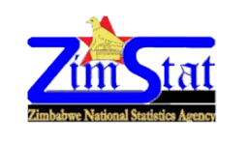

Education and the Labour Market in Zimbabwe

QLFS Q2 2025 – Infographic Fact Sheet

76.8% |  |  | 65.0%
Labour Force | 70.0% | 80.4% | Share of Total
Participation | Employment Absorption | Formal Employment | Employment
Higher Education | Higher Education | Higher Education | Secondary Education

Education Pathway to Better Labour Market Outcomes

Never Been to School | → | 80% Informal Employment
Primary Education | → | 73% Informal Employment
Secondary Education | → | Largest Workforce but Highest Unemployment
Higher Education | → | Best Access to Formal Employment

Key Messages
- Labour force participation increases steadily with education.
- Formal employment rises sharply among persons with higher education.
- Women experience higher labour underutilisation than men.
- Secondary education holders account for the largest share of employment and unemployment.
- Informality decreases as educational attainment increases.

Gender Snapshot
Women | Men
More concentrated in Education, Health & Welfare | More concentrated in Engineering, Manufacturing &  Construction
Higher labour underutilisation | Higher labour force participation

Follow us on:


